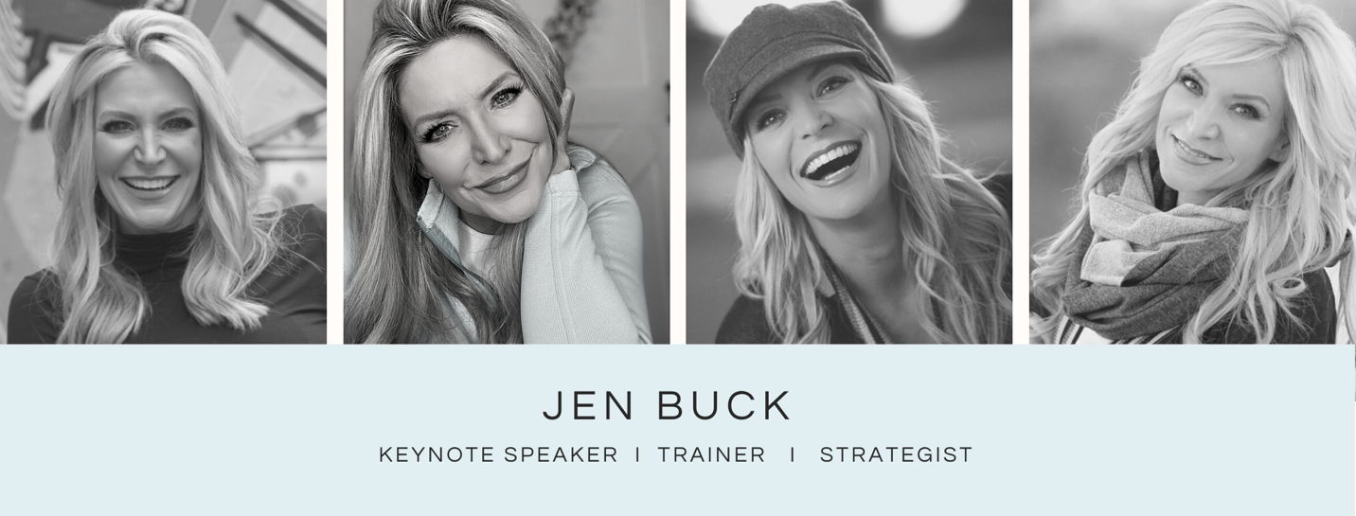

With 30 years of experience as a Professional Speaker and Trainer, Jen Buck’s strength and conviction on the platform have earned her standing ovations and rave reviews, around the world. She began her career in the finance world working for Discover Card, when it was a start-up, and spent ten years as a leader in a training role, where she honed her craft in leadership and employee development.

Jen has spoken to countless numbers of people throughout her 24-year professional speaking career and has delivered keynotes and workshops in front of audiences ranging from 10- 25,000 people. She focuses on leadership and management and is committed to helping teams thrive in an equitable, supportive, and uplifting environment. She has written six books and has a podcast and television show that is seen in 50 countries around the world. Jen is a Certified Professional Coach with three coaching designations who helps people increase their potential so that they can achieve higher levels of success. She has trained and coached 4-Star Generals, the highest-level executives at Coca-Cola and Walmart, and even an Emmy nominated actress—the demand for her knowledge and perspective is very broad. She has recently started an online learning academy for high-performing women and strives to be the driving source of information and development for women who are leading organizations.

Along with running her training company for 24 years, she is also the founder and director of a nonprofit organization that helps families in need in Phoenix, Arizona. Jen has founded several not-for-profit organizations over the years, including a disaster recovery coalition that provided aid on-ground after the Shawnee tornadoes in Oklahoma, as well as a home for at-risk girls in Uganda. Finally, Jen also works in politics as a Chief of Staff and has worked with four U.S. Congressional candidates.

Contact:
jenbuckspeaks@gmail.com
https://jenbuckspeaks.com
480-524-0082

Social Media:
⁃ Instagram/Facebook/LinkedIn/Clubhouse: jenbuckspeaks
⁃ Speakers reel: https://youtu.be/BkFkG8GRuBs
⁃ YouTube channel: https://www.youtube.com/channel/UCfo5Afm7R93PmWgOAttoBDw
- The HERstory Collaborative online academy: https://ttheherstorycollaborative
⁃ Nonprofit website: https://allhandsaz.org

